

Femme Fatales celebrates the alluring women of film, television and pop culture with more sexy photos per page than any magazine of its kind on the market.

Thursday, June 1, 2006

Hanging With Huang
By Dan Scapperotti
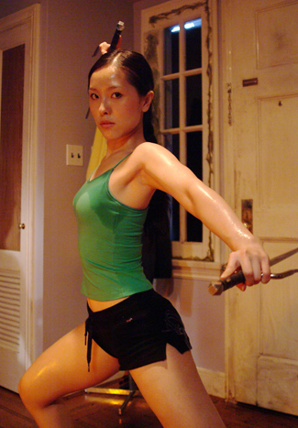
Avoiding slicing mandibles, snapping jaws and infectious slime is all in a days work for the sorority sisters in director Jeff Lando’s horror film Insecticidal. When a chain of events creates a slithering mass of giant insects, the girls of BYI sorority are trapped inside their house and begin falling prey to the critters. One of the girls who doesn’t take it lying down is Fumi, a Japanese exchange student with martial art skills.
“In a weird way I got into acting through literature,” says Vicky Huang who plays Fumi. “Growing up I loved books, I devoured them. I guess living in a different world in someone else’s mind evolved into acting in my early teens.”
Huang began acting while still in school and studied theater in college. She spent a year treading the boards in Ireland before returning to Vancouver where she found work as ethnic characters in television and film before being tapped for her role in Insecticidal.
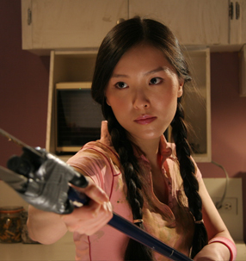
“What is the most interesting thing for me was that the director Jeffrey Lando sort of gave me free rein to do what I wanted with the character,” says the actress who was born in Beijing and speaks Mandarin fluently. “I guess after reading the script, it was really a campy funny script, I didn’t want to make Fumi a really typical Japanese exchange student very meek with a heavy Japanese accent. So she’s a lot more Americanized. What attracted me to the character of Fumi was she is very strong and very intelligent. If you look at her actions throughout the whole thing she’s a survivor and she doesn’t get fazed by adversity. She really just goes for it. I was quite sad that she died. She’s very practical. When she’s dealing with Josi, the queen bee of the sorority house, she pretty much caters to her. I do her homework according to the script. When she comes into my room I’m doing kata and sweating. You can tell that my character has an attitude as well so she kind of plays along with Josi’s game.”
Her marshal arts aptitude is not faked for the camera. Huang spent years training in kick boxing and capoeira, the Brazilian form of martial arts. “It’s very acrobatic and involves combative dance,” Huang explains. “In the beginning I did it for fitness reasons, but then it became the discipline and also it feels good to physically be able to do things. It came in handy because throughout the years on different projects I’ve had to do my own stunts, not full stunts but action stuff.”
The fact that much of the action takes place against rampaging creatures that will be digitally inserted in the editing room didn’t faze the actress. “You react to nothing being there because you have a back story in your mind and you already know how emotionally you’d feel about certain things,” she says. “In your mind there is something there. Part of acting is using your imagination and creating a certain emotion or a certain response. I’ve had occasions where an actor had to leave early for some reason and you have to react to him in a scene. The best situation is having the other actor there to feed you the emotion, to feed you the line and if they’re not there you just have to create that for yourself.”
When Fumi is introduced doing kata in her room, it’s not evident that Huang had never trained in that form of martial arts. She got her training on the internet. “Kata is essentially a whole series of stylized practice movements for martial arts,” she says. “I’d never done kata before so I went onto the internet and downloaded a bunch of sequences. They had different grasps and I created my own kata sequences that may not be authentic but I thought would look good on the screen.”
On the day set for shooting the scene the director added a new element. Huang would have to show dexterity with the sai, the three pronged dagger weapon of choice for Electra, Marvel’s comic book character. “They wanted me to use some weapons as well just to make it interesting,” she says. “The stunt assistant introduced me to the sai that I use in the movie. They’re so much fun to do and I caught on quite quickly. I learned the routine in the morning and I was able to do them quite fast, flip the weapon, twirl it around and jab it.”
That worked out but Lando wanted Huang to be sweating, a lot. “The makeup and special effects people put a lot of glycerin and water on me in order for it to show up on screen. Jeffrey wanted a wet, sweaty look. They put tons and tons on and it’s very slippery. I could feel it running down my arms and legs and it made it difficult to catch the sais. Once I flipped them they just slipped out of my hands. I got very frustrated with that. That was probably the most physically difficult part of the role.”
For a low budget independent film, Insecticidal offered Huang an intimacy not generally available on larger films. “I was really surprised because as an actor you go on the set and you talk to some of the actors a bit but you sit in your trailer most of the time,” says Huang. “You’re on your own especially if you’re a day player. You’re on the set for a period of time but then you go off set and that’s it, but for this film because its shot in a house for nine or ten days with all main characters stuck inside this house its almost like a horror film. You don’t get to go out and you have twelve to fourteen hour days. In a good way we all became friends. A lot of the girls on the show sat around talking and we went out afterwards so that part was neat.”
Recently, Huang appeared in a short film called Hiro which premiered at the Toronto film festival and won the best short at Slamdance. “It’s done in Japanese, I don’t speak in this particular film, but I’ve spoken Japanese for characters before. I sort of learned the language phonetically. It’s a twist on Japanese mobster films. A Japanese insect collector comes into the city to get a rare beetle and while waiting for this person he bumps into this young girl, Vicky. At the end even though he didn’t want to get involved he saves her. It was kind of funny. My character didn’t have a name, but the director enjoyed our performances so much that he thought the characters were us so my name in the credits is Vicky.”
Posted in Femme Features

